
Safety Bay Senior High School
Chemistry Unit 1 & 2

Test #1:
Stoichiometry

NAME: ______________________________________

Reading time: 5 minutes
Working time: 50 minutes

Section | Mark
Multiple Choice | / 5
Short Answer | / 45
Total | / 50

MULTIPLE CHOICE 5 marks
- If X₂O₃ is the correct formula for a metal oxide, the formula for the chloride of X is

  - XCℓ
  - XCℓ₂
  - XCℓ₃
  - X₃Cℓ₂

- Making use of the periodic table, the formula for francium oxide is most likely to be:

  - Fr₂O
  - FrO
  - Fr₂O₃
  - FrO₂

- A gas jar contains 6.022 x 10²⁴ molecules of carbon dioxide. How many moles of atoms is this?

  - 1
  - 3
  - 10
  - 30

- Ammonia gas reacts with oxygen gas according to the following equation:

4 NH₃(g) + 5 O₂(g) → 4 NO(g) + 6 H₂O(g)

Which of the following correctly calculates the number of moles of water produced from 7.80 moles of ammonia?
Note: The relative molecular mass of ammonia is 45.054 and the relative molecular mass of water is 18.016.

(a) | 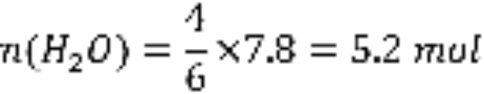
(b) | 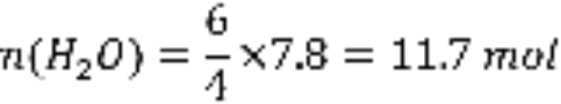
(c) | 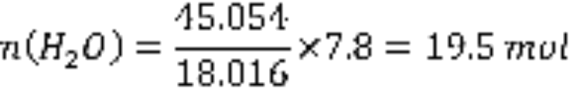
(d) | 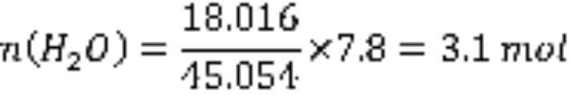

- What values of w, x, y and z are required to balance the following equation?
w Aℓ + x H₂O → y Aℓ₂O₃ + z H₂

  - w = 2 x = 3 y = 1 z = 3
  - w = 2 x = 4 y = 2 z = 6
  - w = 1 x = 3 y = 1 z = 3
  - w = 3 x = 4 y = 1 z = 6
SHORT ANSWER 45 marks
- (3 marks)

Complete the table by writing the formula for each ion.
Ion name | Ion formula
Aluminium ion
Iodide ion
Strontium ion
Nitrate ion
Hydrogensulfate ion
Sulfite ion

- (8 marks)

- Write the formulas of the following compounds:

  - Calcium carbonate:

  - Nitric acid:

  - Lead(II) iodide:

  - Copper(II) chloride-2-water:

- Write the names of the following compounds:

  - CH₃COOH:

  - P₂I₄:

  - CrBr₃:

  - Ba(OH)₂:

- (1 mark)

Give a definition for the term relative molecular mass.

- (3 marks)

Complete the table below to show the symbols used to represent various measurements in chemistry and the units in which they are measured. The first line has been done as an example.
Measurement | Symbol | Units
Mass | m | g
Number of moles
Molar mass
Relative molecular mass

- (2 marks)

Calculate the molar mass of the following substances.

- Ammonium nitride, (NH₄)₃N (1 mark)

- Cobalt(II) chloride hexahydrate, CoCℓ₂•6H₂O (1 mark)

- (2 marks)

Calculate the number of moles of magnesium atoms in:

- 70.0 g of magnesium metal (1 mark)

- 0.568 mol of magnesium phosphate, Mg₃(PO₄)₂ (1 mark)

- (3 marks)

Calculate, to three significant figures, the number of water molecules in a 200 mL glass of water.
(Note: 1 mL of water has a mass of 1 g)

- (5 marks)

Arsenic-containing compounds have high levels of toxicity. It was widely used as a poison in the middle ages due to its lack of colour and odour and because its symptoms mirrored food poisoning or other disorders.

- One common form of arsenic used as a poison in the Roman Empire was arsenic trioxide (As₂O₃). Calculate the percentage by mass of arsenic in this compound. (2 marks)

- Arsenic poisoning can be deadly above levels of 11 mg of arsenic per 1 kg of body mass. What mass of arsenic would be required to kill a person with a body mass of 80 kg? (1 mark)

- Calculate the mass of arsenic trioxide (in mg) which would be required to deliver the dose of arsenic calculated in part (b). (2 marks)

- (8 marks)

An organic compound was known to contain the elements carbon, hydrogen and oxygen only. Combustion of the organic compound produced carbon dioxide and water, and from the masses of these respective products it was determined the compound consisted of 40.0% carbon and 6.67% hydrogen.

- From the data provided, calculate the empirical formula of the compound. You must clearly show all working. (5 marks)

- Mass spectrometry revealed that the same organic compound had a relative molecular mass of approximately 180. Suggest a molecular formula for this compound and explain how your answer is consistent with all of the evidence given. (3 marks)

- (5 marks)

One type of fire extinguisher depends on the reaction of sodium hydrogencarbonate with sulfuric acid to produce a salt, water and carbon dioxide. The equation for the reaction is:

2 NaHCO₃ + H₂SO₄ → Na₂SO₄ + 2 H₂O + 2 CO₂

- Write the name of the salt formed in this reaction. (1 mark)

- Calculate the number of moles of NaHCO₃ in 500 g of sodium hydrogencarbonate. (2 marks)

- What mass of sulfuric acid would be required to react completely with 500 g of sodium hydrogencarbonate? Clearly show all working. (2 marks)

- (5 marks)

- Metallic iron can be produced from the reaction of iron(III) oxide with carbon monoxide, with carbon dioxide gas produced as a by-product. Complete the balanced equation by writing the chemical formula for each substance in the boxes. (1 mark)

2 |  | + 3 |  | → 4 |  | + 3
 | Iron(III) oxide |  | Carbon monoxide |  | Iron |  | Carbon dioxide

- What mass of iron(III) oxide (in kg) would be required to produce 160 kg of metallic iron? Clearly show all working. (4 marks)

SPARE WORKING PAGE
If you use this page to continue an answer from a previous question, you must indicate near the question that your answer continues on this page. If you do not indicate this then the answer on this page will not be marked.

